**Lab Report #02**

**Experiment Name #** Different Commands in Linux Operating System.

**Aim and Objective:**

The purpose of the experiment is to learn how different commands work on Linux operating system. Different command serves different purpose for executing various programs.

* To use Linux operating system effectively.
* To learn about different commands.
* To learn the purposes of different commands.
* To get the best of Linux operating system.

**Experiment:**

**Whoami :**

This command shows who logged on the system. Here the system is mint.

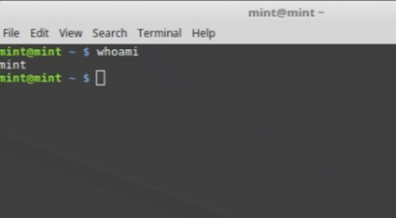

**Hostname :**

This command shows on which machine you are in.

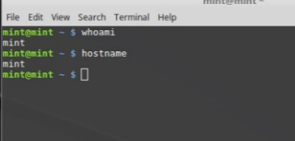

**Pwd :**

pwd command shows the current directory in which you are in. Here directory is /home/mint.

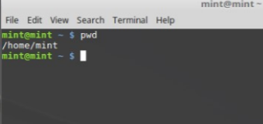

**Ls :**

ls command shows the list of files of working directory.

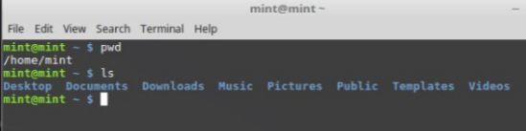

**Man<any command name> :**

man command is used to get the detail information of any command written next to ‘man’.

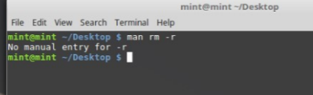

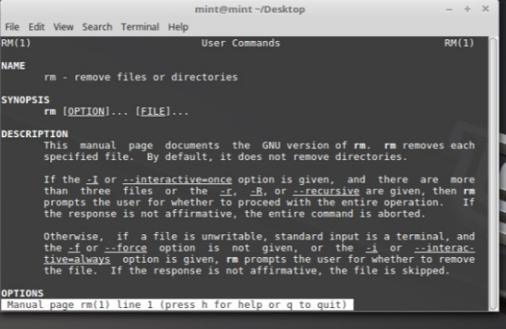

**Mkdir <dir_name> :**

The mkdir command is used to create directory with specific directory name that is defined in the command. We can also create a directory inside another directory using mkdir command.

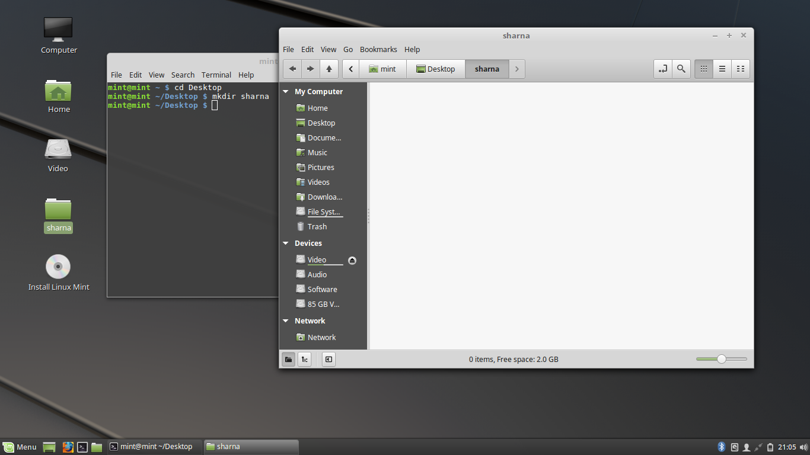

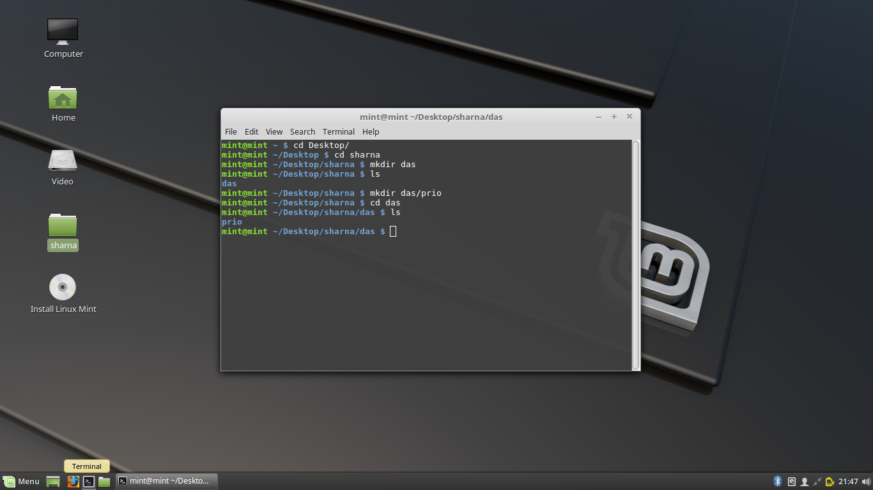

**Cd :**

cd command is used to switch the directory written next to cd command.

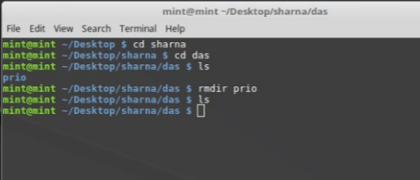

**cd .. & cd ../../ :**

cd .. command is used to move one directory up. cd ../../ command is used to move two directory up. cd is used to move to the highest level of one’s home directory.

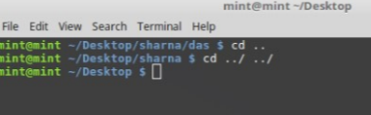

**rmdir<dir_name> :**

rmdir command is used to remove the entire directory if the directory is empty.

**rm <file_name> :**

rm command is used to remove the file name in a directory.

**rm –r<dir_name> :**

rm -r command is used to remove a directory including all its files.

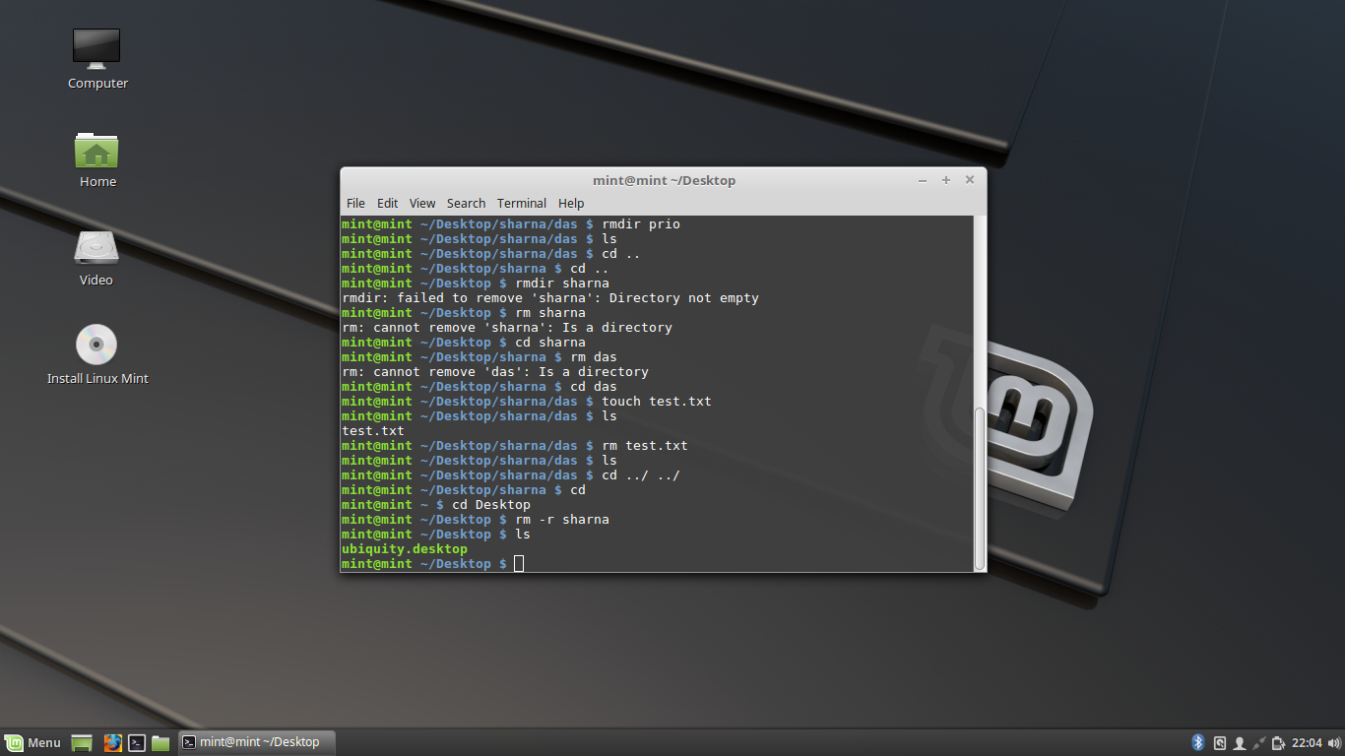

**mv<name1> <name2> :**

mv command is used to rename any directory or files.

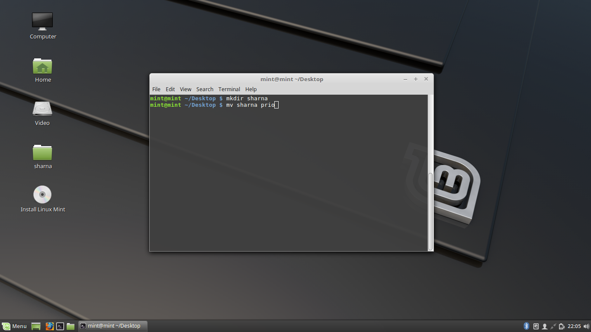

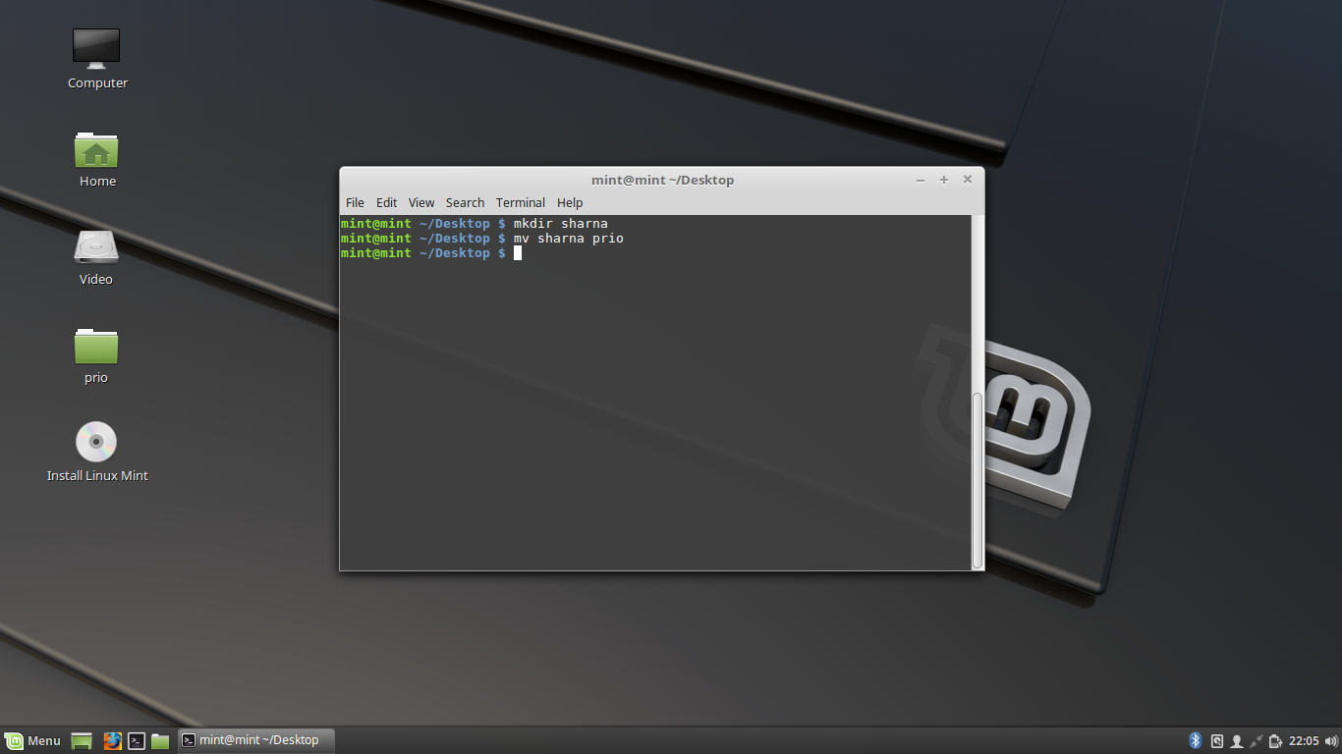

**Conclusion:**

Through this experiment of executing different commands I learn the basic commands of Linux operating system. I learn whoami, hostname, ls, pwd, mkdir, cd, rmdir, rm, rm –r, mv commands. This helps me to create a directory, a file and go to the directory, remove file or directory and rename operation. This expands my way of future applications on Linux operating system.